**REPORT**

**Voyage Vista : Illuminating Insights From Uber Expeditionary Analysis**

**Introduction:**

Voyage Vista: Illuminating Insights From Uber Expeditionary Analysis" serves as the gateway to understanding the exploratory analysis conducted on Uber's data. It likely introduces the objectives, scope, and methodologies of the analysis, highlighting how the project aims to uncover valuable insights from Uber's operational data. It might also offer a glimpse into the significance of the analysis in enhancing business strategies and decision-making processes within the company. Overall, the introduction section sets the tone for the comprehensive exploration of Uber's data, potentially providing an overview of the data analysis techniques and tools employed throughout the project.

**Purpose:**

Illuminating Insights From Uber Expeditionary Analysis" are not explicitly mentioned in the search results. However, based on the title, it can be inferred that the article likely aims to provide illuminating insights derived from Uber's expeditionary analysis. These insights might include valuable information about Uber's operational strategies, data analysis, or possibly their business expansion plans and market insights. Furthermore, the article could shed light on how Uber utilizes data analytics and technology to enhance its services and improve customer experiences.

**Data literacy**:

"Voyage Vista: Illuminating Insights From Uber Expeditionary Analysis" appears to be a data analysis project aimed at providing insights to Uber drivers to help them make informed decisions regarding their driving efforts, focusing on efficiency and profitability [1]. The project likely involves analyzing data from Uber's operations to identify patterns, trends, and potential areas of improvement for drivers. It emphasizes the importance of data literacy, utilizing tools like Tableau for data visualization and analysis [2]. The insights derived from this analysis could help drivers optimize their routes, time management, and target areas with higher demand, thereby enhancing their overall performance.

**Measure talent management success**:

In the context of measuring talent management success, Voyage Vista's insights from the Uber Expeditionary Analysis can be leveraged to evaluate various key performance indicators (KPIs) related to talent management. Some potential metrics include employee retention rates, performance appraisals, training and development program effectiveness, and overall employee satisfaction surveys. Additionally, analyzing data on employee engagement, leadership development, and succession planning can provide valuable insights into the effectiveness of talent management strategies [[1](https://nm.smartinternz.com/saas-guided-project/1/voyage-vista-illuminating-insights-from-uber-expeditionary-analysis)]. By gathering and analyzing data on these factors, businesses can assess the success of their talent management initiatives and make informed decisions to optimize their workforce for better organizational performance and productivity.

**Problem definition and Design thinking:**

**Empathy map:**

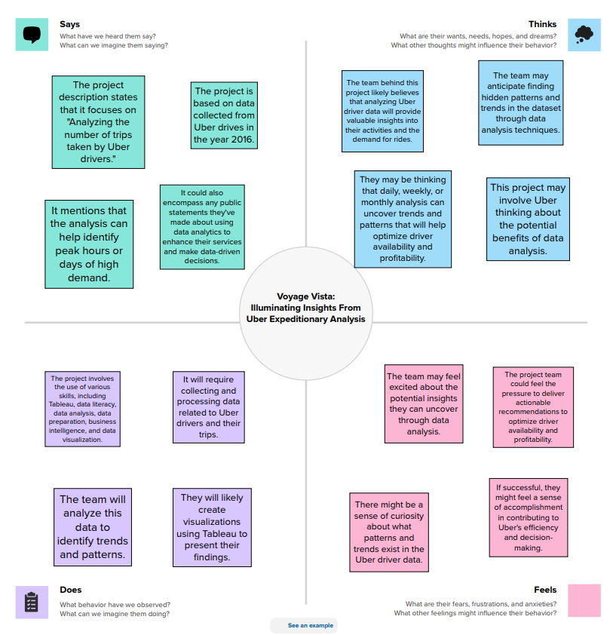

**Brain Storming:**

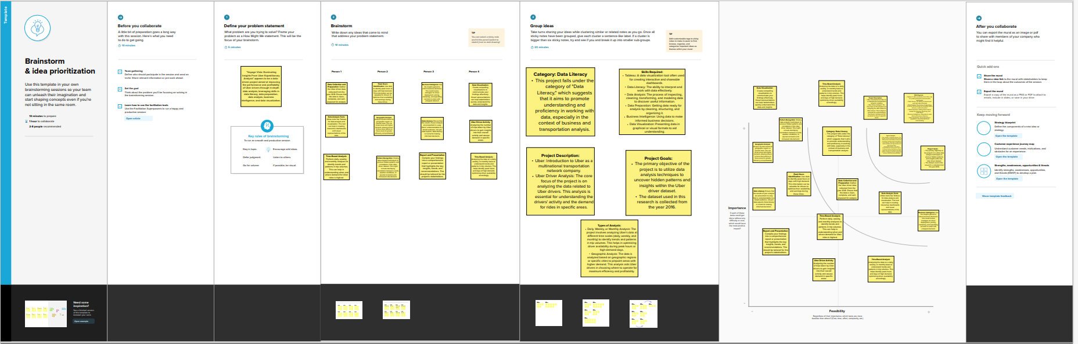

**Dash Board:**

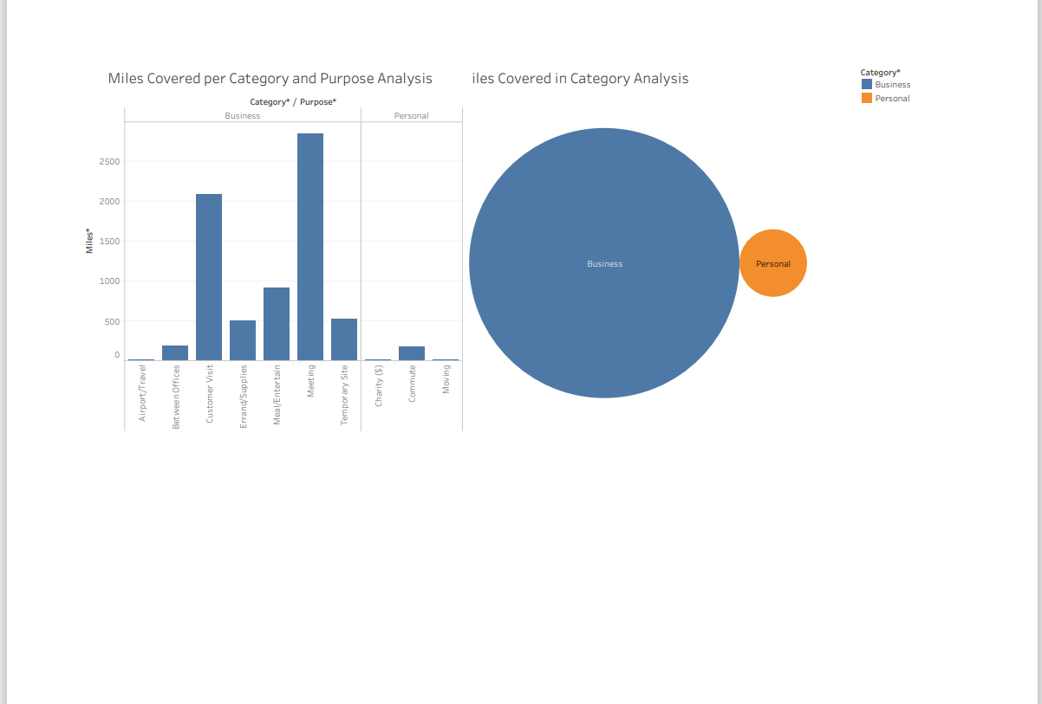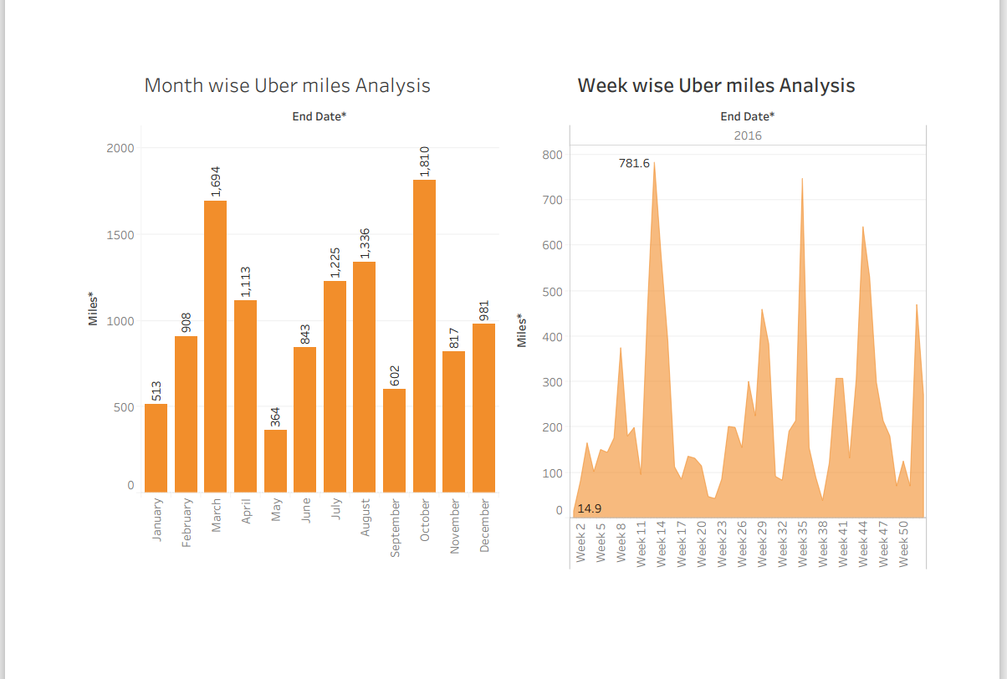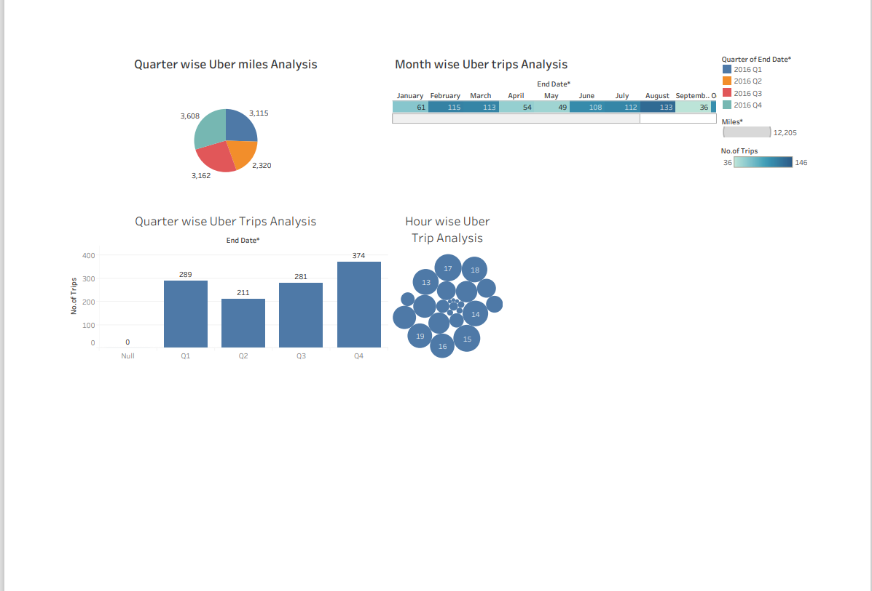

**Story:**

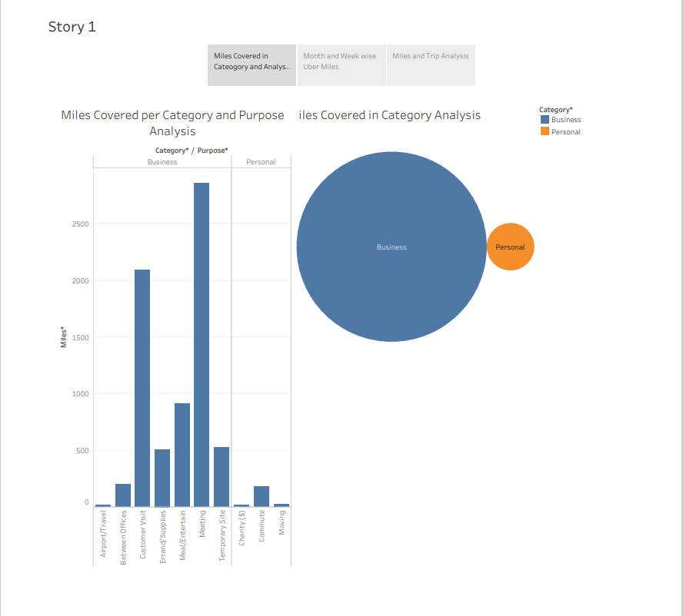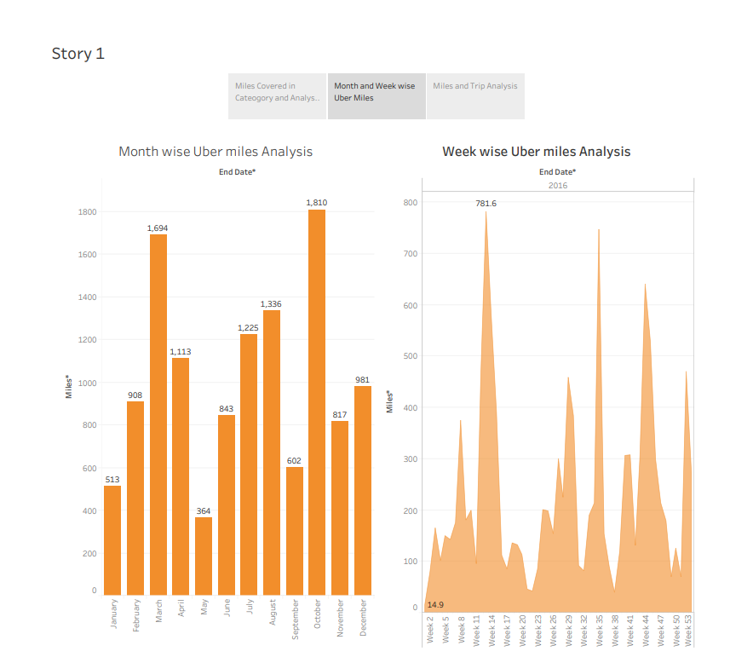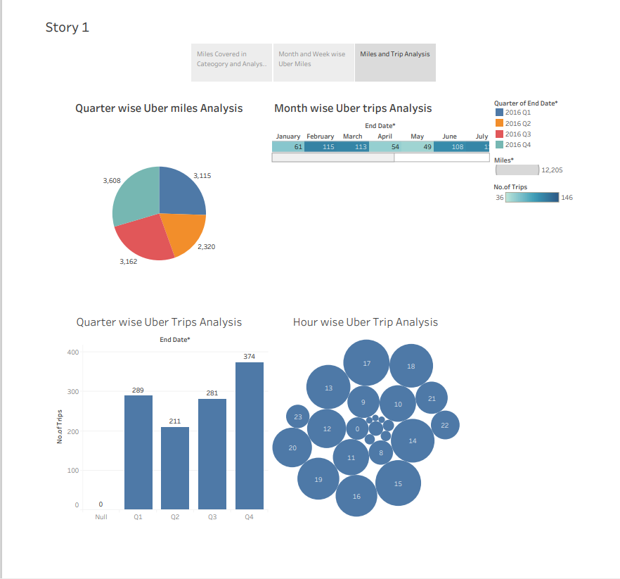

**Advantages and Dis advantages:**

**Advantages:**

* Efficiency Boost: Insights from the analysis can help Uber drivers focus their efforts on high-demand areas, leading to better efficiency and increased profits [1].
* Data-Driven Decision Making: With the help of data analysis, Uber can make informed decisions to improve its services, streamline operations, and enhance customer satisfaction

**Dis Advantages:**

* Data Privacy Concerns: Uber's extensive data collection practices raise concerns about the privacy and security of user information
* Regulatory Challenges: Uber's disruptive business model has often faced regulatory challenges, leading to legal battles and increased scrutiny from authorities.

**Applications:**

Voyage Vista, an Uber expeditionary analysis, offers crucial insights for drivers to optimize their driving efforts, enhancing efficiency and profitability [[1](https://nm.smartinternz.com/saas-guided-project/1/voyage-vista-illuminating-insights-from-uber-expeditionary-analysis)]. This analysis helps drivers determine where to focus their efforts, considering factors such as peak hours, popular locations, and customer preferences. By utilizing data literacy techniques like Tableau, drivers can visualize and comprehend the data, enabling informed decision-making for maximizing earnings and providing better services [[2](https://nm.smartinternz.com/externship-nm-projects/41)]. The comprehensive analysis of Uber's data aids in understanding customer behaviors and market trends, facilitating the identification of potential growth opportunities [[6](https://medium.com/@hafsabatul.cse/uber-data-analysis-fee3eded7c56)]. Moreover, by gaining insights into the dynamics of the transportation industry, drivers can navigate the pros and cons associated with platforms like Uber.

**Future Scope:**

* Enhanced data-driven decision-making processes for Uber drivers, enabling them to identify high-demand areas and plan their routes efficiently
* Implementation of similar analytical methodologies across other transportation sectors to enhance operational efficiency and customer satisfaction.
* Integration of advanced data visualization tools such as Tableau to further enhance data understanding and business intelligence
* Potential applications of the project's data exploration and visualization techniques in other industries beyond transportation for market analysis and strategic planning.

**Conclusion:**

The analysis of Uber expeditionary data can provide crucial insights for drivers to optimize their driving efforts and enhance profitability. By leveraging data literacy and tools like Tableau, drivers can identify peak hours and high-demand areas, thereby maximizing their efficiency and earnings. This project's objective is to equip drivers with the necessary data literacy skills to make informed decisions based on market trends and customer preferences. Overall, through this analysis, drivers can strategically plan their routes, understand customer behavior, and adapt their services to meet the evolving demands of the market.